QA POLICIES
THIRD MISSION

Table of contents

Table of contents
1. THE THIRD MISSION CONTEXT 1
1.1 RESEARCH DEVELOPMENT 2
1.1.1 The Context of the Scuola 2
1.1.2 Management of intellectual property 3
1.1.3 Creation of companies, spin-offs and start-ups 3
1.1.4 Relations with the industrial context 4
1.1.5 Research development projects and initiatives 5
1.1.6 Technology Transfer Networks 5
1.1.7 Placement 7
1. 2 PRODUCTION OF PUBLIC GOODS 8
1.2.1 Impact on schools 10
1.2.2 For and with the citizenry 12
2. THE ACTORS INVOLVED IN QUALITY ASSURANCE PROCESS 15
3. TOOLS FOR QUALITY MONITORING 16
4. QUALITY ASSURANCE FLOW CHART 17
5. PERSPECTIVES AND ACTIONS 19

1. THE THIRD MISSION CONTEXT
The civil and social commitment of the Scuola Normale in spreading the culture and value of research is an integral and constitutive part of its identity. The Statute (art. 2. c.1), in fact, states that "the aim of the Scuola Normale is to promote the development of culture, teaching and research in the field of mathematical and natural, human and social sciences, exploring their interconnections" and for this reason "it pursues the highest level of education, university and post-university, lifelong and periodic, giving priority to the link between education and research, for an enhanced interaction with the outside world". The Third Mission has a synergistic and structural relationship with education and research and is one of the key tools through which the Scuola Normale contributes to the economic, technological, cultural and social development of the local area, the country and the international community.
The dialogue with society, the openness to citizenry, the selection of priority partners such as upper secondary schools and specific productive sectors, are driving forces that deeply influence the planning of the Third Mission activities of the Scuola Normale, which can be easily outlined and summarized via the macro-repartition indicated by ANVUR, in Valorizzazione della ricerca e Produzione di beni pubblici.

1.1 RESEARCH DEVELOPMENT
The concept of research development is based on the assumption that research results can be absorbed by the industrial system in order to promote the development of innovative goods and services. However, the same notion of development can be interpreted in different ways: from a key condition for economic development and the creation of technological poles in a territory, to an indicator of the efficiency of a State's national innovation system, to a mere capacity for the management and commercial exploitation of inventions deriving from research activities.
Research development therefore has a field of application that is not limited to the production of new industrial technologies, services and goods, but also to the impact it has on the social and economic context. Therefore, certain technology transfer activities are not easily visible and measurable, especially in the short and medium term. Research development activities are hence numerous, often interconnected and complement the traditional educational and research missions of Universities, which also features the placement service as an intermediary agent with the production sector.

1.1.1 The Context of the Scuola
Over the last few years, following the strong impetus of the Governance, the Scuola has focused massively on research development activities.
The trend in the number of new protections is positive, with particular reference also to the strategies for their extension in the countries of major interest for their possible economic exploitation. Furthermore, the strong commitment to technology transfer activities has led to the recognition between 2019 and 2020 of the Scuola's first three spin-off companies, some of which will supposedly be licensees of the Scuola's patents. Considering the increasing interaction with the industrial context, the activity of the NEST Regional Competence Centre has been consolidated, the National Competence Centre Artes 4.0 has been activated and private companies have shown their desire to activate, in addition to research projects on behalf of third parties, joint laboratories with structures of the Scuola. In order to create a broad, challenging and constant dialogue context for development and enhancement policies, it is also worth noting the Scuola's commitment to establishing and strengthening relationships and networks with public and private bodies. The quality in the context of the Valorizzazione della Ricerca (Research Development and Enhancement) is translated into the commitment to network in such a way that the knowledge produced by the Scuola through scientific research is actively transformed into productive knowledge, with economic applications for the improvement of the country.
The monitoring of each initiative helps to understand the extent to which quality is pursued and the results achieved.

1.1.2 Management of intellectual property
Description of the procedure for the filing of a new patent: proposal of the researcher and/or professor, request to the Joint Technical Committee JoTTO for a prior opinion on patentability (in the case of a patent deriving from institutional research projects, prior transfer of the rights by the inventors).
The strategy of extension and maintenance of the protection is defined in agreement with the inventors and co-owners.
Support activities:
- enhancement of the patent portfolio on the Knowledge Share platform;
- clearance search (e.g. ORBIT database, Espacenet);
- promotion and support of academic staff at Research2Business (R2B) events, fairs and competitions on regional, national and international level (es. Borsa della Ricerca - Salerno, InnovAgorà -Milano);
- preparation and negotiation of IP licensing/assignment/management agreements.
Internal reference sources: Regulations for the protection and development of industrial property of the Scuola Superiore Sant'Anna, Scuola Normale Superiore, Scuola IMT Alti Studi di Lucca and Scuola Universitaria Superiore IUSS di Pavia: https://www.santannapisa.it/sites/default/files/regolamento_per_la_tutela_e_la_valorizzazione_della_proprieta_industriale.pdf

1.1.3 Creation of companies, spin-offs and start-ups
Due to the strong interest in entrepreneurial initiatives, it is worth stressing the important review of the Regulations for the establishment and recognition of spin-off and start-up companies: https://www.sns.it/sites/default/files/normativa/2018/regfr6.pdf
In line with this strategy, the number of spin-offs was also chosen as an indicator for the 2019-2021 Three-Year Programme (TITLE OF THE PROGRAM: Knowledge transfer and sharing OBJECTIVE: B ACTION/I: B_C - University spin-offs - B_and - Number of university spin-offs ).
Description of the recognition process for spin-off or start-up companies:
- entrepreneurial proposal of the researcher and/or lecturer, PTA (Three-year Activity Plan) of the Scuola;
- opinion on the technical and economic feasibility and development prospects of the JoTTO Joint Technical Committee's entrepreneurial project;
- binding opinion of the Governing Council on the absence of conflict between the spin-off/start up company's target service or product and the Scuola's own activity in relation to education, research and technology transfer;
- resolution of the federated Board of Directors regarding the economic and financial sustainability of the initiative and its benefits for the Scuola as well as on:
  - proposals for agreements regulating the relationship between the Scuola and the spin-off/start up company;
  - participation of the Scuola in the share capital of the spin-off companies determining their amount and duration;
  - granting of authorisations for the participation of the Scuola's staff in the spin-off/start up, insofar as it falls within its competence (subject to the opinion of the competent body: Class Council is responsible the academic staff and Secretary General is responsible for the PTA).
Additional activities: promotion of financial instruments to support the development of business ideas and business creation (subsidised finance, public tenders, investment funds); participation in the MiSE POC Call for proposals with the project "Joint Universities' programme for PoC- JUMP". Partnership composed of SSSA and University of Palermo. Pending the outcome of the evaluation.

1.1.4 Relations with the industrial context
- Third-party research projects (See Research Quality Policies) in the following areas:
  - Physics of Matter, Nanoscience and Nanotechnology (prevalent);
  - Neurobiology;
  - Computational Chemistry, Virtual and Augmented Reality;
  - Mathematics for Finance, Cultural Heritage, Archival Heritage Management;
Participation in projects with industrial partners and mapping of relevant contacts
- Competence centres
  - NEST Laboratory Regional Competence Centre, launched in 2015 as a result of the experience gained at the NEST Laboratory - National Enterprise for nanoScience and nanoTechnology. The Centre provides services such as certifications, measurements, nano-materials manufacturing, consulting, training, research contracts to companies that design and manufacture nano-scale devices. (http://www.laboratorionest.it/inaugurazione-centro-di-competenza-nest-sulle-nanotecnologie/)
  - ARTES 4.0 National Competence Centre (MiSE), Advanced Robotics and enabling digital TEchnologies & Systems 4.0. The Centre provides counselling and training services to enterprises for the implementation of innovation, industrial research and experimental development projects. The Scuola participates in the Centre with the Macronodo Artes4.0@SNS. (https://artes4.it)

1.1.5 Research development projects and initiatives
- Academic education for entrepreneurship.
Training courses aimed at increasing entrepreneurial skills for the Scuola's staff:
  - Contamination Lab Pisa (funded by MIUR, partners: SNS, SSSA, UNIPI, IMT);
  - Start Cup Toscana (funded by Giovanisì Regione Toscana project, partners: NS, SSSA, UNIPI, IMT and in collaboration with PNI - Premio Nazionale per l’Innovazione National Award for Innovation - its further national level);
  - "Tuscan Start Up Academy 4.0” Project, presented on the ROP ESF (Regional Operational Programme co-financed by the European Social Fund) 2014-2020 of the Region of Tuscany (UNIFI -project's leader-, SNS, IMT Lucca, UNIPI, SSSUP). Educational courses: "SMARTVH - Virtual Worlds and Augmented Reality in Cultural Heritage", "PLATCAP - Platform capitalism and the new worker movement", "SNSProEU - Scuola Normale Superiore per la Progettualità Europea"
  - “Estrazione dei Talenti” Project presented on the ROP ERDF-ESF 2014-2020 of the Apulia Region (joint participation as JoTTO). Initiatives aimed at the unemployed and initiatives of lifelong and/or specialized and professionalizing training. Financed project.
- Interdisciplinary IP training activities for lecturers, researchers, post-doctoral researchers, PhDs and students;
- Opportunità della Ricerca (Research Opportunities) Website: the main calls for research and TT are available on the website for all interested public;
- Internal scouting in the laboratories: drafting of a questionnaire aimed at mapping the staff's awareness of the issue of IP protection, with particular reference to the specific research activities of the relevant structure;
- Enhancement of the organisational unit (See Research Quality Policies, Research and Technology Transfer Service - single organisational unit):
  - AFR Grants - activation of 2 advanced education and research-action courses - Year 2019, under the ROP Objective "Investment for growth and employment" ESF 2014-2020.
  - TT@SNS Mise Project for the financing of enhancement and capacity building projects of Technology Transfer Offices (UTT) of Italian Universities - activation of a Knowledge Transfer Manager position.
  - The office has also been reinforced with 2 post-doctoral researchers financed by the ARTES 4.0 - Advanced Robotics and enabling digital TEchnologies & Systems 4.0 Competence Centre.

1.1.6 Technology Transfer Networks
Since 2008, the Scuola has been a member of NetVal, the Network Valorizzazione della Ricerca Universitaria (Network for the Development and Enhancement of University Research). The mission of Netval is the dissemination of TT information and culture through initiatives aimed at bringing together the Technology Transfer Offices of universities through meetings, training courses and participation in thematic groups. Specifically, the association promotes the dissemination and enhancement of public research competences, both at university and other levels, in the field of research development, knowledge transfer and intellectual property protection, with specific reference to the creation of academic spin-offs and the exploitation of patents through licensing or transfer of their related rights; the promotion of the culture and good practices of technology transfer also by involving the corporate world; the support to the legislator on policies related to the enhancement of public research results. Furthermore, Netval fosters interaction with both national and foreign ministries and bodies and the participation as Italian representative in the European association ProTon Europe and similar initiatives. (Netval: Home)
JoTTO (Joint Technology Transfer Office) is the Joint Technology Transfer Office of the Scuola IMT Alti Studi Lucca, the Scuola Normale Superiore, the Scuola Superiore Sant'Anna in Pisa and the Scuola Universitaria Superiore IUSS Pavia. On 1 October 2015, the three universities signed an agreement for the establishment of the Office and approved the Policy for the management of technology transfer activities. On 1 April 2017, the Scuola IUSS Pavia also joined the initiative. Since 2020, two other top-level entities, SISSA and GSSI, have also joined the initiative.
The Joint Office provides a service to schools as part of the Third Mission of Universities, in order to identify new strategies for the promotion of research results through the protection of intellectual property, the generation of spin-offs/start-ups and the activation of collaborations with companies.
JoTTO's mission is to promote the development and use of knowledge to contribute to the social, cultural and economic development of society, through a common strategy for promoting the coordination of intellectual property management within the framework of agreements with the external bodies involved through European, national projects or research contracts; promoting and disseminating the results of university research by favouring its exploitation in companies and bodies; intensifying links with industry and making new technologies, knowledge, research staff and structures available to companies; providing support to teachers and researchers in identifying the productive and commercial spin-offs of their discoveries, also through the creation of "spin-off companies".
In particular, the main activities carried out involved the organization of training days for academic and non-academic staff, the JoTTO Fair, - 2019 edition Research Meets Business (at the IMT premises in Lucca on 9 and 10 May 2019: about 50 representatives of the research community from the 4 Universities and from Sissa and GSSI, over 40 participating companies and 120 B2B meetings) and the realisation of the JoTTO video (filmed in the 4 locations of the Universities and interviews with the 4 delegates/pro-rectors at TT) with launch on 29 October 2019 on social networks TTO).

Since 2018, the Scuola has been a member of TOUR4EU, Tuscan Organization of Universities and Research for Europe, a non-profit association under Belgian law based in Brussels, founded upon the initiative of the Tuscany Region. All of the seven Tuscan universities participate in the network. The mission of TOUR4EU is to promote the interests of the Tuscan research system in Europe. More specifically, the association interacts with the EU institutions to identify the best opportunities and funding, as well as to encourage collaboration between researchers and other European partners. Moreover, the association encourages scientific cooperation aimed at fostering the interaction of universities with the Tuscan industrial world, also acting as a reference point for mobility and transnational cooperation policies in support of universities' research programmes. Finally, it favours synergies between the Region, the business world and universities, promoting 'smart specialisation' strategies and the consolidation of the regional ecosystem for innovation and cooperation.(Tour4eu – Universities and Research for Europe).
During 2019, the Scuola signed a Collaboration Agreement with the Region of Tuscany and the other Universities of the Region in order to widen the regional technology transfer network, which provided for the establishment of a Regional Technology Transfer Office (URTT). The Toscana Life Sciences Foundation (TLS), through a subsequent agreement, was included in the project with the operational management functions of URTT. The mission of URTT is to enhance the capacity of transfer of research results, achieved by Tuscan Universities and High Schools, to the productive system with special focus on regional SMEs. As far as enhancement and development activities are concerned, the main objectives of the URTT include: coordination and management of the information of the "regional portfolio" of intellectual property, through the use of liaison IT tools, also in order to provide results for the benefit of local SMEs; as regards initiatives at regional level, assistance and support in dealing with financial institutions and intermediaries authorised to finance technology transfer initiatives, in particular to channel resources for PoC purposes, including those related to the ITATech platform, which manages the resources of the European Investment Fund and the Cassa Depositi e Prestiti; dissemination on the territory of information on regional technological capacity, also by using regional information tools, including the toscanaopenresearch.it platform, in order to encourage the use by SMEs of local departmental structures for the performance of contracted research activities; support to the management of the Region of Tuscany in the definition of enhancement tools within the regional R&D funding measures in favour of universities, research bodies, small and medium enterprises, also in coordination with the UVaR.

1.1.7 Placement
In early 2019, placement and career counselling activities were stepped up, partly as a result of requests made on several occasions by the students, who over the years have also become more interested in professional objectives other than traditional academic ones.
The systematisation process of the Placement service activities was aimed at creating an office with the role of contact point and facilitator both for students and external parties, planning and implementing a series of initiatives for the best matching between supply and demand of opportunities. This process has involved:
- the definition of standard procedures consistent with those used by other services (e.g. in relation to internships);
- the use, development and enhancement of placement tools (portals);
- the updating of the relevant website pages and the implementation of the placement portals and tools for a structured management of other activities (documents, forms, use of computerised procedures for applications and requests to the service);
- the collection and management of structured data concerning each initiative and users;
- a system planning closely connected with the Services: Communication and External Relations Service, Internationalisation Service and Research and Technology Transfer Service.
Within this context, the project aimed at the alumni networking is particularly significant. Not only does it aim at collecting updated contact information from alumni, but it also seeks their active involvement in the current affairs and events of the Scuola, providing a solution to the mentoring and placement needs of current students, as well as in terms of participation in research networking, sharing of interests and research results, enhancement and exploitation of results also through academic and corporate partnerships.
Alumni therefore play a major role, as:
- students can get inspiration to imagine their own future, even beyond the more traditional schemes and paths, i.e. alumni can serve as valuable interlocutors for career counselling;
- they are highly important for companies as they help the latter to really get to know the Scuola through their own career paths and results.
The Alumni network can thus be useful to promote knowledge and positioning of the Scuola beyond the academic community, fostering interactions with the labour market and more generally with society.
The network demonstrates the centrality of students in the quality process of the Scuola.

In a nutshell, the activities planned and managed entirely by the office: (https://www.sns.it/it/placement):

Placement Service for students and alumni  - internships (curricular and non-curricular);  - Placement seminars (meetings also with former students, company presentations, series of seminars on professions in collaboration with the career centre of the University of Pisa);  - personalised career counselling;  - portals for the supply/demand matching (AlmaLaurea and JobTeaser);  - JobFair. | Services for companies and institutions  - portals for the demand/offer matching (AlmaLaurea and JobTeaser) for the publication of opportunities and collection of applications, as well as viewing the CVs of students enrolled;  - request for agreements on traineeships;  - joint planning of customised placement initiatives;  - JobFair (targeted company scouting, starting from the needs of students, aimed to invitation to events) | Alumni and Mentoring  - initiatives coordinated with the Associazione Normalisti (database and alumni network project);  - Mentoring (organisational assistance and support to the demand/offer matching).

1. 2 PRODUCTION OF PUBLIC GOODS
The Scuola Normale has undertaken numerous actions to transform and make available the knowledge produced outside the academic sphere, even before the university's dialogue with the social and productive context was acknowledged under the common label of "Third Mission". The Scuola is firmly rooted in the conviction that its task is also to spread the results and meaning of research, so that the whole of society may benefit. Consequently, a number of initiatives with a social and cultural impact were promoted. These have enriched, perfected and expanded over the years and throughout ages of social and communicative change: recovery and sharing of the historical-artistic, archaeological and book heritage, lifelong education and Public Engagement activities. This range of actions can be broken down into two strands, which are substantially different according to the target audience: 1. upper secondary schools; 2. general public.
A list is provided below, while a more detailed description can be found in the following section:
1.2.1 upper secondary schools
a) vocational courses
b) soft skills courses and vocational counselling (PTCO)
c) Classroom lessons (La Normale va a scuola)
d) continuing education for lecturers
1.2.2 general public
A. Institutional initiatives
- I Venerdì della Normale (Fridays at the Scuola Normale)
- Talks by the Faculty of Science
- Conferences and research dissemination initiatives
- Seminars, conferences, debates on current and social-political issues
- Series of seminars: Movimenti nel mondo
- Participation in initiatives involving the local area (Internet Festival, Researchers' Night)
- Visits to the Palazzo della Carovana
- Partnership with the Luigi Pecci Contemporary Art Centre in Prato for the promotion of contemporary artworks
- The “Scuola Normale” Concert Season
- The “Scuola Normale” Cinema
B. Student initiatives
- FAcT - Festival of Academic Theatre
- Readings at the Scuola Normale
- Student Forum
C. Cross-cutting initiatives (publication and dissemination of video materials on the YouTube channel)
All the activities described below, barring the Concert Season of the Scuola Normale (in any case free for students of the Scuola), are open to the public for free, in a perspective of concrete social commitment and dissemination of research and culture. The bond with the Scuola's sites, Pisa and Florence, is very tight and the participation of citizens in the events is quite high.
This wide-ranging array of initiatives has grown and diversified over time thanks to the institutional commitment, the dedication of the organizers and the enthusiasm of the public. The Scuola's historical initiatives, today an integral part of its tradition (counselling, concerts) are backed up by a well-established system of programming, implementation and ex post monitoring that takes into account both quantitative (on the number of initiatives carried out) and qualitative parameters, obtained through customer satisfaction surveys. The feedback collected is one of the pillars on which the Scuola develops subsequent editions. The same approach has been extended to more recent initiatives - such as the training courses for lecturers and the distance learning initiative La Normale va a scuola - and will be progressively extended to all the latest or newly conceived experimental initiatives that the Scuola intends to launch. The establishment - in January 2020 - of a special Commission in charge of planning, coordinating and monitoring the Third Mission activities of the Scuola Normale on the production of public goods is a decisive step in this direction. The systematisation of the current initiatives will take place without prejudice to the possibility of launching and experimenting with new initiatives, both on an institutional and individual level, with the constant aim of generating engaging and effective forms of development and promotion of culture. Structured planning can also further enhance the value of the Scuola's brand, enabling adequate communication of its social value, also for possible fundraising initiatives. In this regard, it is important to consolidate relations with the alumni of the Scuola Normale, involving them in specific initiatives that contribute to promoting the image of the Scuola also in non-academic contexts, both nationally and internationally, and to create opportunities for placement and exchange with the students.
As regards the evaluation and assessment of Third Mission activities, there are inherent difficulties in the use of univocal parameters, especially because the impact of the actions can be seen over a very long time frame, while some initiatives are one-off or are limited to a short period. In any case, the Scuola monitors and proposes to broaden the evaluation of the impact of all the activities and their relative commitment in terms of specific economic and human resources, through the use of Key Performance Indicators (KPIs) as shown in the reporting documents (performance report, research report, education and technology transfer activities, feedback report to the partners of initiatives). Some of the indicators concern the number of initiatives carried out (both face-to-face and distance initiatives) categorised by type, target, number of participants, cost and involvement of external actors in the implementation.

1.2.1 Impact on schools
In 1966, the first pilot university vocational courses organised by the Scuola Normale were held in Erice. These courses became fully structured - initially thanks to ministerial funding - in 1980 and have continued to this day. The vocational courses offered are unique compared to those offered by other universities: they do not aim to promote the educational activities of the Scuola Normale, but to provide participants with the tools to identify and enhance their potential and interests and to consciously choose their university studies. The Vocational Courses are reserved for worthy students of the fourth year of Italian and foreign high schools. Upon selection - made based on merit - students can participate in special events with lectures and conferences by representatives from a wide range of disciplines and professions. In an atmosphere of dialogue and exchange - with professors, tutors and peers - students can make informed, conscious, knowledgeable choices about their future academic studies. In addition to the courses organised independently by the Scuola Normale, in 2017 the University Vocational School was established, as a result of the agreement for a joint action between Scuola Normale, Scuola Sant'Anna and IUSS of Pavia.
The Scuola Normale also welcomes high school students to its premises for Soft skills and vocational Courses (formerly Alternanza Scuola/Lavoro), which concern: scientific dissemination, archive and library management, collaboration with laboratories; it also arranges visits for schoolchildren (as well as for groups and individuals) to its historical sites, laboratories and libraries. Students also actively participate in this dialogue with schools, through initiatives supported on an institutional level, such as the multi-year course of integrative education and workshops with the Liceo Classico G. Galilei in Pisa and the experimental project I cerchioni di Dante, an initiative against early school leaving organised in collaboration with IPSIA (Professional State Institute for Industry and Craftsmanship) in Pontedera. During this specific initiative, a mixed group of pupils from IPSIA and the Scuola Normale prepare the public reading of some famous excerpts from the Divine Comedy.
Last spring, the privileged relationship with schools also produced a significant, albeit sudden, outcome. In order to cope with the closure of schools due to the health emergency, and the consequent difficulties experienced by students and teachers, the Scuola Normale provided all Italian secondary schools with concrete support: its teaching and research staff gave live distance lessons to interested classes on current and research topics. The response of schools and teachers was immediate and enthusiastic: this is how La Normale va a scuola project came to life, a huge and impressive initiative that counted 233 live lessons (divided into 12 subjects and held by 33 lecturers), in which more than 47,000 students from all over Italy participated. The recordings of the lessons were then collected in a playlist which is now freely available to students and teachers on the Scuola's YouTube channel (https://cutt.ly/JfxJics)
The Scuola Normale was established with the aim of conveying the "norms" of teaching and train future schoolteachers. Over time its mission has changed, and it has focused on education for research: generations of scholars have acquired cutting-edge methods and contents, passing them on to the academic world, as well as to universities and to the widest range of business, cultural and social contexts. The relationship with teachers, however, has not faded over time and has found new vigour since December 2012, when the Scuola joined the national continuing education programme created the previous year by a memorandum of understanding between the Accademia Nazionale dei Lincei and the Ministry of Education: the programme is aimed at training Italian teachers in schools of all levels, promoting and developing initiatives aimed at spreading scientific and humanities culture in Italy and restarting the virtuous dialogue between schools and universities. The training courses for teachers provided by the project aim to support and encourage the improvement of national education and training systems, taking advantage of the scientific and educational contribution of Academies, Universities and cultural institutions, to the development of a cultivated, educated, critical, curious and informed citizenry, as well as to the creation of an inclusive school, the driving force behind justice and social promotion. By embracing and fostering this philosophy, the courses organised by the Scuola Normale (Accademia dei Lincei and Normale per la Scuola) have been a benchmark for teachers in Tuscany's schools and in the surrounding regions since their inception.

1.2.2 For and with the citizenry
The Scuola Normale runs a rich programme of cultural initiatives in the most varied fields of knowledge, arts and sciences, also from an interdisciplinary point of view, aimed at a lay public.
The Venerdì della Normale project, inaugurated in 1981 under the name of "Venerdì del Direttore", consists of a series of public conferences arranged on a Friday, in which prominent personalities from the world of culture, research, politics, meet students and staff of the SNS, as well as the public, opening to a wide audience the participation in talks on important and current topics.
On the research communication side, the Scuola Normale arranges, in addition to the Talks of the Faculty of Sciences (monthly seminars held by specialists of international level, dedicated to topics of general interest concerning Biology, Chemistry, Physics and Mathematics and accessible to a wide audience), series of meetings on different research fields, also interdisciplinary in nature, where teachers, researchers - both in-house and from other institutions - present to the general public the results and key aspects of their studies, often connecting them to current topics. In Florence, where the Faculty of Social and Political Sciences and the Institute of Advanced Studies C.A. Ciampi are based, seminars, conferences, debates, documentaries on the topics of participation, the relationship between politics and society and the political economy are held, with a focus on the relationship between the state and the market, also addressed to a non-academic audience. The knowledge produced by the Faculty of Social and Political Sciences and by the Ciampi Institute, due to the nature of the activities and the research subjects promoted, translates into a continuous dialogue and interaction with policy makers, local public bodies and foundations, citizens. The "Movimenti Del Mondo” project is an initiative in which scholars of the forms of political participation critically discuss with the protagonists of these processes in order to offer an all-encompassing vision, trying to identify the global trends underlying individual local events.
The events are structured in two different parts: the projection of a documentary and a meeting with the protagonists and scholars of the phenomena.
The Scuola also plays an active role in initiatives organised in collaboration with local institutions and bodies: from the Internet Festival to the Researchers' Night, during which conferences and guided visits are organised to disseminate and promote the activities carried out in the laboratories.
The enhancement of the artistic heritage is another activity that the Scuola Normale has carried out in recent years through guided tours for groups, school groups and citizens in the Palazzo della Carovana, in the Library (Palazzo dell'Orologio, Palazzo del Capitano), in laboratories and research facilities. In this perspective, since 2012 the Scuola Normale has started a collaboration project with the Centro per l'Arte contemporanea Luigi Pecci of Prato, which has brought contemporary art works to the unusual setting of the 16th century, Vasari-designed, Palazzo della Carovana. The aim is to highlight the dialogue and the close interaction between the world of scientific research and that of artistic creation, also in the aspects related to historicisation and museum promotion. These works are a testimony to contemporary culture and call those who attend the Scuola Normale on a daily basis, as much as guests and visitors Palazzo della Carovana, to grasp the richness and complexity of contemporary languages.
Furthermore, the Scuola Normale has been involved for many years in a project - at the forefront when it was launched - which actively promotes and promotes musical culture. The Concerti della Normale project was launched in 1967 upon the initiative of Gilberto Bernardini (Dean of the Scuola Normale at the time) and the violist Piero Farulli. The idea, which has remained unchanged to this day, was to offer students of the Scuola and the general public of the city (and of the local area) a programme that alternated a traditional musical repertoire with more sophisticated and unusual genres, while acknowledging classical music as a fundamental part of our culture and encouraging individual growth. Ever since then - under the direction of Piero Farulli, Andrea Mascagni (1987 - 1993), Carlo de Incontrera (1993 - 2013), Jeffrey Swann (2014 - 2016), and now Carlo Boccadoro - the concert season, organized in collaboration with the Fondazione Teatro di Pisa and with the financial support of the Pisa Foundation, has been a tradition of the Scuola Normale, offering a journey through different musical eras and styles, instrumental interpretations and compositional genres, together with open introductory classes that delve deeper into poetics, periods and styles, to stimulate further thoughts and reflections in the audience.
During the summer, in the Vasari-designed Piazza dei Cavalieri (where the Scuola Normale is located), Il Cinema della Normale, an open, themed film festival, has also been held for a few years now. The films are preceded by an introduction to the topic by the Scuola's research staff. For two years now, Piazza dei Cavalieri (along with other areas of the city) has hosted FAcT, the International Academic Theatre Festival organised by the SNS theatre group of students, in June. In addition to the possibility of performing, the Scuola Normale offers board and lodging to participating university companies from all over Europe. FAcT was created to build an international network of the most interesting university theatre companies and to organise an event that involves not only students, but the whole city, which for three days every year is constantly populated with theatre-related events. Also connected to the activities of the theatre group is an experimental project of collaboration with the detainees of the Don Bosco prison in Pisa that has led, with the support of the Association called I Sacchi di Sabbia, to the performing of readings and interpretations in prison.
Furthermore, the public is actively involved in the Readings at the Normale (also an initiative of the Scuola's students), group readings that last one or more days and in which the public is requested to participate, with its multiple voices, in the public reading of different works. During these sessions, the lecturers of the Scuola Normale hold public talks that deal with different aspects of the work in question. Over the last few years, readings of the Italian literary classics have been performed: from Promessi Sposi (The Betrothed) to Orlando furioso (The Frenzy of Orlando), from Dante to Leopardi. During the spring of the lockdown, the organisers of the Readings at the Normale, invited readers to virtually repeat the experience of the ten young protagonists of Boccaccio's Decameron. The "allegra brigata", made up of over 450 readers from all over the world, read, remotely, the hundred novels of the Decameron, for a total of two months of online events, and over 200 hours of reading, entirely available on the Scuola Normale's YouTube channel. This experience also inspired the online album "Dieci canzoni. Boccaccio, Decameron”, in which some of the protagonists of the Italian independent music scene have produced a work that ranges between genres, ages and musical tastes.
Another initiative conceived and arranged by the Scuola Normale's students is the Forum degli Allievi (Student Forum), which stems from the desire to participate in the Scuola's cultural activities, to reflect on contemporary reality and to bring students of the Scuola Normale closer to the business world. These are public meetings with relevant personalities invited for their expertise in the areas being discussed. The structure of the meetings reflects the nature of a forum: in fact, these are not lectures, but rather interactive debates between guest speakers, as well as students, lecturers and the general public.
The contribution of students to activities aimed at schools and the public is encouraged and supported by the Scuola Normale, which favours, by Statute, "self-managed educational activities of students in the fields of culture and cultural exchanges, sport and leisure" (art. 12 par. 1), as an experience of individual growth and an important stimulus to responsibility and social commitment.
The main tools through which the Scuola Normale promotes its Third Mission activities are the institutional website, the web newspaper NormaleNews, the Scuola Normale Superiore YouTube channel and the other institutional social channels (Twitter, Instagram and Facebook). Conferences, seminars, special events, presentations and training lessons are made available on YouTube at no charge a few days after events or in live streaming. These materials have a high educational and dissemination potential, which - if properly treated and included in a structured and consistent communication plan - can make a decisive contribution to the societal impact of the Scuola Normale's research, allowing - thanks also to the interactivity of social media - a direct involvement, a real "engagement" of the public, and a greater dissemination of knowledge transfer. Digital storytelling and social channels are an essential support to the impact of traditional in presentia communication.

2. THE ACTORS INVOLVED IN QUALITY ASSURANCE PROCESS

The functions and purposes of the main subjects involved in the quality cycle of the third mission are summarised below.
Subjects involved in the whole quality cycle of the third mission and their role within the institution:
- Governance bodies
- Class councils
- Evaluation Team
- Quality Control Unit
- Joint lecturer-student Commissions
- Research and technology transfer service
- Communication and External Relations Service
- Events and Site Management Service
- Organisation and Assessment Service
Actors involved in the quality cycle of the third mission in the field of RESEARCH DEVELOPMENT:
Joint Technical Commission JoTTO
It consists of a permanent unit of members (one for each Scuola that is part of JoTTO) and can be extended by the presence of other members selected on each occasion among the professors and researchers of the Scuolas or externally depending on specific needs and proposals made by the Scuola, which submits the dossier to the Commission for examination. The Joint Commission expresses its opinion on the issues and activities reported by the Scuolas, i.e. on issues relating to intellectual property and business creation, in the time and modalities specified in the regulations.
Research Committee
It is chaired by the Pro-rectors of research, assessment and ranking and by the three Deans of the Scuola's Academic Faculties. Each new research project is subject to the evaluation of the Research Committee, which verifies its compliance with the guidelines and development lines of the Scuola in the field of research determined by the Academic Board. The Research Committee also expresses its opinion on the scientific interest of project proposals and makes sure that these do not hamper the smooth running of the Scuola's educational and scientific activities.
Actors involved in the quality cycle of the third mission in the field of PUBLIC GOODS PRODUCTION:
Third Mission Committee
It is chaired by the Delegate of the Dean of Education, Third Mission and Accreditation and is composed of professors from all the disciplinary areas of the Scuola. The Third Mission Committee is responsible for proposing, planning, programming and monitoring activities related to Vocational Courses, La Normale va a scuola, Venerdì del Direttore and various initiatives for the dissemination of research. The Third Mission Committee also has the task of collecting, systematising and monitoring proposals for events aimed at non-academic audiences made by research staff.
Coordinators of the Site of Pisa (Accademia dei Lincei and Normale for schools)
The coordinators of the Site of Pisa for the I Lincei per una nuova didattica nella scuola (a coordinator and three managers of the main disciplinary areas involved, Italian, Sciences and Mathematics) project coordinate the planning, programming and monitoring of teacher training courses, serving as a bridge between the three institutions involved (Accademia dei Lincei, Scuola Normale Superiore and University of Pisa).
Art director of the concert season
The Art Director of I Concerti della Normale, appointed by the Scuola's Director, is responsible for programming - in agreement with the Fondazione Pisa and the Fondazione Teatro di Pisa, partners in the initiative - and monitoring the concert season.
FAcT Coordination
It consists of a group of SNS students and oversees planning, organising and monitoring activities related to the Festival of Academic Theatre (FAcT), the Readings at the Normale and the prison theatre project.
Student Forum Coordination
It is composed of a group of SNS students and plans, programmes, organises and monitors the activities of the Student Forum.

3. TOOLS FOR QUALITY MONITORING

The principles that govern the Quality Assurance of the Third Mission of the Scuola Normale can be summarised as follows:

- systemic and integrated approach to the Scuola's activities, in order to shape its processes and facilitate the identification of interdependent relationships, the actors involved and the implementation methods.
- constant monitoring and evaluation of the outcomes of the processes implemented, in order to detect the degree of fulfilment of the objectives and estimate stakeholder satisfaction, thus ensuring the effectiveness of the entire quality system.
- timely implementation of corrective actions to improve the system.

The following tools are used to ensure the quality of the process:
- production of specific documents (SUA/TM, minutes of the Third Mission Committee, reports as part of the three-year planning, performance report, report on research, training and technology transfer activities);
- monitoring/dialogue meetings with the actors involved in the cycle;
- information flow through requests and proposals managed by the various bodies involved in the third mission and governance in all phases of planning, implementation, monitoring and reporting;
- customer satisfaction surveys and employment outcomes;
- surveys aimed at assessing the initiatives proposed by the targets involved.

4. QUALITY ASSURANCE FLOW CHART

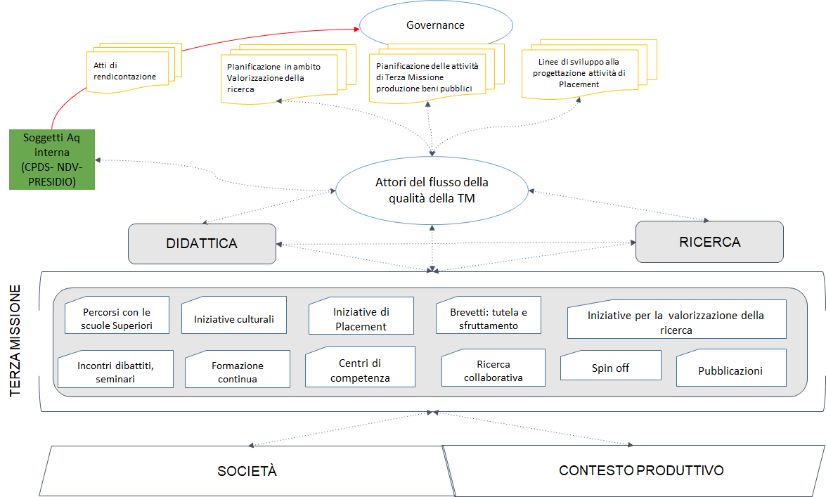

Phases of the quality cycle of the Third mission in the field of Research Development

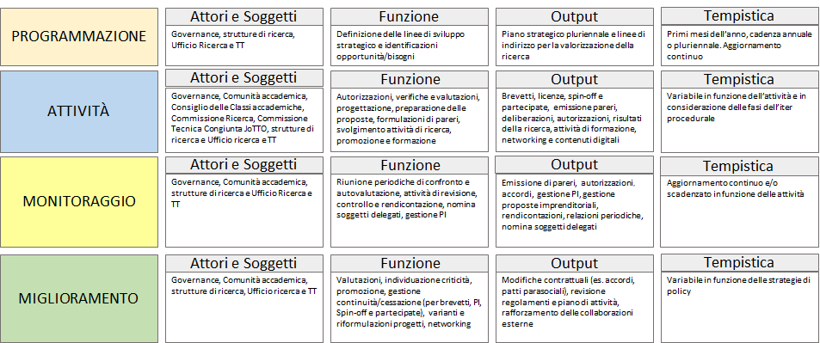

Phases of the quality cycle of the Third mission in the field of Public Goods Production
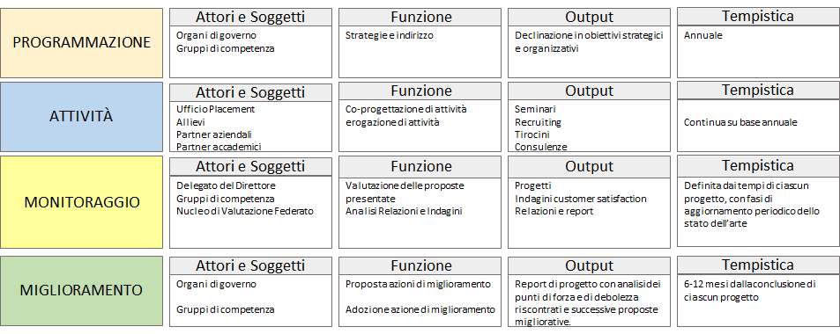

Phases of the quality cycle of the Third mission in the field of Placement activities
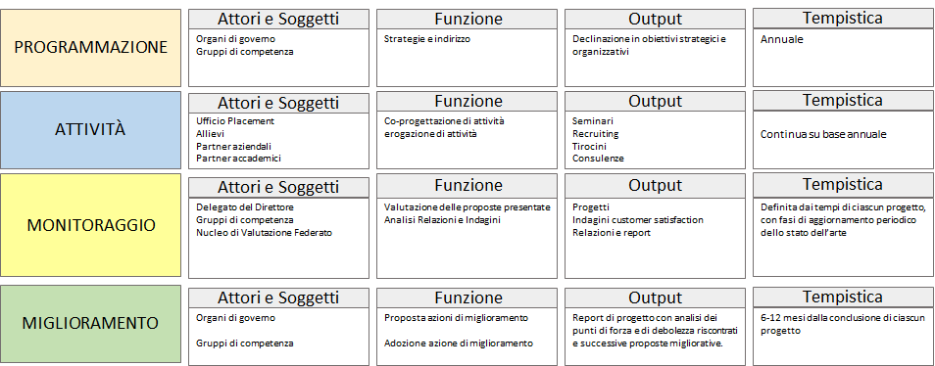

5. PERSPECTIVES AND ACTIONS
Unlike Education and Research, Third Mission activities - due to the diversity of their initiatives and outputs - cannot be based on a consolidated and univocal set of measurement and evaluation indicators. International literature has suggested several sets of uniform indicators for the mapping and monitoring of processes and products in terms of efficiency, effectiveness and impact, without reaching a univocal solution; in the VQR 2015-19, ANVUR adopted the methodology of case studies for the mapping of public goods production activities. The Scuola Normale is constantly committed - through a comparative analysis of the various monitoring and evaluation systems operating at international level and with a particular focus on the approach of the relevant national evaluation authority - to identifying adequate indicators to enhance the specificity level of the planned initiatives, promoting their continuous growth and improvement with a view to quality assurance.
As regards both the development and enhancement of research and the production of public goods, the Scuola Normale is carrying out a mapping of all initiatives that produce an impact on society, whether voluntary or more structured, also with a view to greater enhancement and promotion, and thus efficiency. The interaction with the outside world and the transfer of knowledge to society can be achieved through a combination of coded information, which is easier to monitor (e.g. publications, patents, licences for collaboration contracts), and implicit information (informal interactions during meetings and events, mobility of students, researchers in the productive or social sector) that needs to be made transparent and communicated more and more effectively.
This will enable the Scuola to systematise and develop what is already present, without compromising the intrinsic innovative and spontaneous nature of many activities related to the Third Mission. As far as innovation is concerned, a further strengthening of the already existing link with Education and Research will be strategic, and the relationship with the alumni community - both in academic and non-academic contexts - will play a central role in co-planning initiatives, implementation of educational programmes, sharing of knowledge for the benefit of the community and in terms of innovation and interdisciplinarity. The consolidation in the use of IT, which we had the opportunity to experience during the COVID emergency, will also be fundamental in other areas: originally a parallel and ancillary tool, it has become an essential support for relationships that were previously inconceivable that broadened the scope and impact of our activities.
The commitment of the Scuola Normale in the dissemination of knowledge and in making the research results transparent and widely shared is confirmed by the recent enactment - in June 2020 - of the Regulation on open access to scientific literature, and by the creation of a University Commission for Open Access (see Research Quality Policies): a further step forward in the sharing of knowledge, which completes the range of activities outlined above and that will be systematically consolidated in the years to come.

The various initiatives are however monitored by means of precise indicators described in the specific reports (Performance Report, Report on research, training and technology transfer activities, Report on the three-year ministerial programme).
ANVUR defines Public Engagement as the set of activities organized by the University on an institutional level, non-profit, with educational, cultural and community development value and addressed to a non-academic audience (See Guidelines for the filling out of the Single Annual Third Mission and Social Impact Sheet SUA-TM/IS for Universities, version dated 7 November 2018, available onhttps://www.anvur.it/wp-content/uploads/2018/11/SUA-TM_Lineeguida.pdf)
https://www.sns.it/it/orientamento https://www.sns.it/it/normale-va-scuola-un-aiuto-alle-scuole-ditalia-0 https://www.sns.it/it/terza-missione/formazione-insegnanti-accademia-dei-lincei-normale-scuola
https://www.sns.it/it/attivita-culturali
https://www.youtube.com/user/ScuolaNormale
See. THE PROJECT AT A GLANCE: “I Lincei per una nuova didattica nella scuola: una rete nazionale” (https://www.linceiscuola.it/progetto/)
https://normalenews.sns.it/

